9/2/21

Parent Survey On Remote Learning results

Dear parents
Thank you for your responses to our remote learning survey. We received 23 responses which equates to 33% of the 70 children we have on roll, and is a good level of feedback. Below are the results: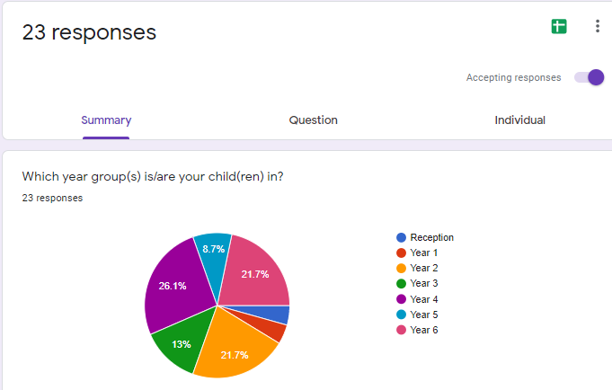

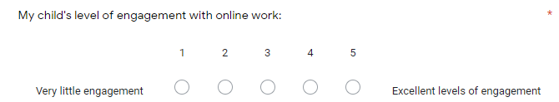
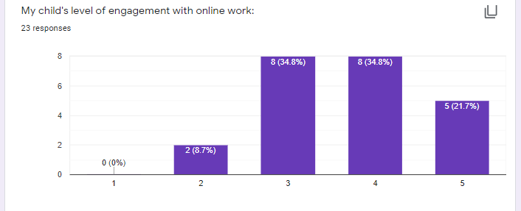
91% of responses show excellent to good levels of engagement, with 8.7% having little engagement.
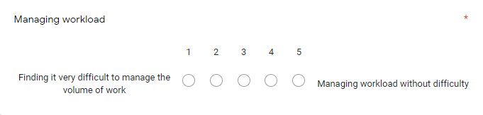
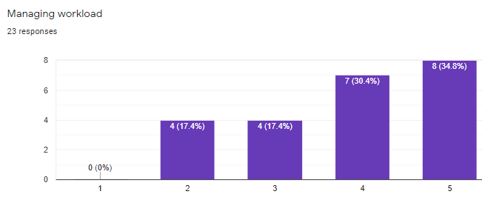
88.6% are managing the workload without difficulty to ok. 17.4% are finding some difficulty.

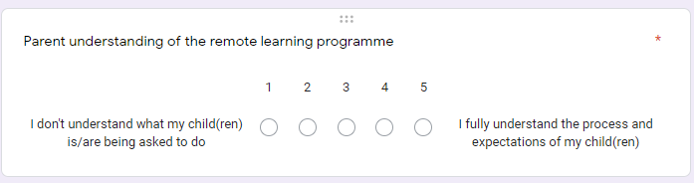
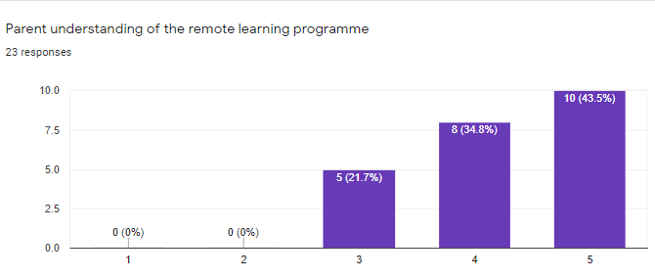
100% of responses show parents fully understand to satisfactorily understand the remote learning programme.
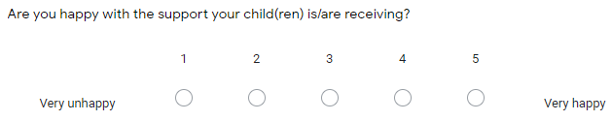
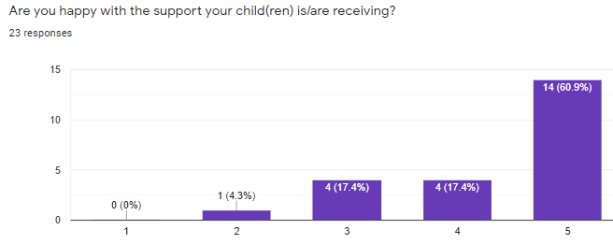
Responses show 95.7% of parents are very happy to happy with the support their child(ren) are receiving, with 4.3% unhappy.

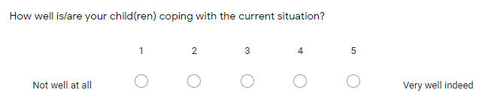
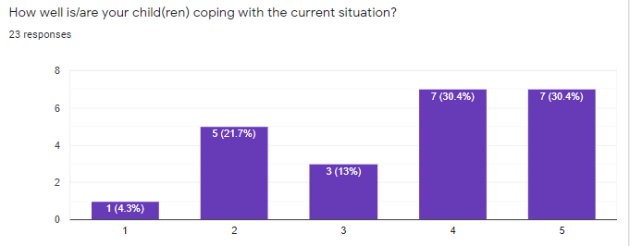
74% of responses show children are coping very well to ok, 26% show not coping well, to not well at all.
Responses to ‘What is going well with home-learning’ ( Names have been anonymised)
- Work provided is of a good standard for my child.
- Maths
- Most of it, just sometimes we the parents need a bit of help with subjects
- I like the timetable as there is a structure to the day and we try to keep to this.
- Mrs Irwin/ Mrs Brown sends paper copy home with ****** for Friday which works well.
- Maths is all good, nice doing work together
- ********* is enjoying the zoom calls and seeing familiar staff members and friends
- ********* is coping with the work ok and managing to get through it all. She is missing the school environment, her teachers and friends. Seesaw works well for us & not having to stick to a set timetable as ***** is on conference calls & meetings all day & I work from 11.15 until 1.45 each day & some evenings which means work is done around this & we catch up in the evenings and weekends. We would not be able to stick to a set timetable.
- It’s varied and easy to follow for us parents as well as the children.
- The work uploaded is great. Feedback on tasks completed is detailed.
- ******** is struggling with home learning, mainly concentrating on his work as he wants to be off doing his own thing.
- ****** is trying his best but missing his friends
- Maths
- ****** is working hard & getting through her work.
- My child is struggling with home learning
- The editable art history work went the best - Anglo Saxon brooch - the maths and English would not get down independently without a lot of parental input.
- She’s pretty much getting through the work sent on a daily basis
- Starts maths every morning by 8am
- Easy to access, at the right level, excellent communication from teachers
- My child does not enjoy home learning. It’s a situation they are expected to accept. I am not a teacher and my child cannot understand the difference between Mum and teacher!
- All of it
- Reading
- With Zoom calls so she can see her friends

Responses to ‘How could we improve the remote learning programme?’
- Having time off online work - other non-technology activities
- It would be better if I could go on all apps to help my child but my phone screen isn’t big enough and no Ipad
- More lessons online
- I am satisfied with the way it is.
- It can be difficult on the iPad and laptop to complete some work set, trying to write on Seesaw response is sometimes tricky.
- Sometimes find the English hard to understand what to do
- More interaction online
- For the most part I would say it is ok, it is hard with the RE & science for example where she would benefit from class discussions but understand this is not possible to do at the moment. Maths seems to be ok & she finds the English hard to get motivated to do. Maybe some more PE challenges, they are getting bored of PE with Joe.
- I don’t think it needs any improvements
- No complaints
- He does seem to listen & pay more attention when his teachers are in the videos. He is not keen on reading on a screen, maybe we could have some books instead.
- Nothing you are all doing an excellent job
- Less amount. It's overwhelming for us.
- ****** finds it hard to concentrate on things that are just being read, she likes it better when she can see a person. For example she struggles to concentrate on the history slides & gets distracted easily. She is also not wanting to do PE with Joe anymore, she does like the other PE activities.
- I think my child would benefit from zoom lessons, as it is a struggle, while the work is being taught in class children at home could join via zoom/teams so they can listen to how the work is explained and if they need help they can ask the teacher
- Some Direct contact with teachers when working remotely - though a lesson a week or something.
- Happy with it she’d like a weekly phone call
- I believe class sessions on TEAMS when teachers are actually teaching a lesson and children can be taught and interact as a class. TEAMS offers break away room so children can go into different groups, this could help with close support and TAs can be utilised more. There is no well-being calls being made to the children, weekly calls to parents to discuss any matters arising or discussion regarding progression should be a regular occurrence by now.
- Maybe a bit more explanation on some subjects
- Works well, good detail plan for the day. Some of the sites we can’t access.
- Happy with it as it is
- Can’t see how it could be improved.

Responses to ‘How do you think school and staff have managed lock-down learning?’
- Very well
- Very well
- Excellent
- Have been supportive and we've enjoyed the Zoom assemblies and class meetings.
- Their preparation and input has made my life a lot easier.
- Mrs Irwin and Mrs Brown are doing a fabulous job, They are both always available via email or Seesaw queries, they responds to any concerns or questions I have.
- Mrs Irwin has been fantastic, it is nice to know that she is there if ****** needs anything, even though there is not much that can be done with regards to what ***** really needs - to be back in school but she has been very supportive & the twice weekly Zoom meet ups do cheer ******* up. Being able to see & interact with her teachers and friends. Work is very well organised and emails sent beforehand when things are needed for science experiments for example.
- I think a lot of effort has been put in to ensure the children have access to all that they need. We have been very impressed with it all.
- Lots of thought has gone in to make learning at home accessible for children and parents.. Keep up the good work!!!
- It has been great to get almost instant feedback on the work they have done. The work is very organised with the expected work each day.
- It has been very organised with a timetable of the days work & they have enjoyed getting their dojos for their work and certificates.
- School and staff are doing the best they can in a difficult situation
- As best as they can with a small school and limited staff; seesaw is a good platform to use - I would like to see more maths that could be edited and answered online rather than copying out, photoing and submitting
- I realise this is a pandemic and different education settings offer different structure/support. But no interaction on a 1-1 bases with families or children at any point is not beneficial or helpful. ZOOM calls to read a chapter of a book and ask how each child is, work being uploaded every evening and a timetable of what’s expected is not supportive or understanding. Each child has a different home life and mental health and well-being at this time I believe is not being considered!
- Fantastic. Can’t fault what your all doing
- Can’t fault the staff
- Very well.
- Lots of thought has gone in to make learning at home accessible for children and parents.. Keep up the good work!!!

