Preventing and Managing Sickness (including outbreaks) Risk Procedures and Risk Assessment
Progression of restrictions / Staged Response
The 4 stages for when dealing with medical incidents/outbreaks (dependent on the nature of the situation and stage)

Response Stage | Trigger | Key Actions | Who | Notes
STAGE 1 – General  (everyday hygiene and procedures) | None | - General reminders for hygiene  - Effective handwashing facilities and soap available  - Follow usual absence periods for sickness | All
STAGE 2 – Prevention | Where an increased risk is present:  - Increased absence rates  - Local increases in sickness eg flu, gastric, coronavirus  - Public health alerts  - Suspected cases of specific illness (school or community - eg Coronavirus/gastric) | - Increase hygiene procedures  - Communication with key people including key information  - Specific hygiene lessons in class  - Increased enforced use of handwashing  - Enforce 48hr after symptoms have stopped for all fever, sickness, diarrhoea etc  - Consider the types of trips and events and make changes as necessary  - Review Core Control Measures and make changes as necessary  - Daily review of the situation | All  HT  All  All  DFE/LEA HT
STAGE 3 – Mitigate/Delay | Where a significant risk is present:  - direct case or increased likelihood of cases  - Public health advice for restrictions | - Consider reducing contact situations:  - Consider sending home any children with any symptoms  - Consider additional cleaning including deeper cleans on public health advice | All  LEA/ HT
STAGE 4 – Containment | Where specific and/or significant changes or restrictions need to be in place:  - High levels of sickness  - High rates of absence  - Significance of danger of disease or illness | - Part/full closures of site/classes  - Deep cleans  - Closure of lettings and building use  - Reduction or exclusion of visitors  - Follow public health advice | DFE/LEA/HT

Coronavirus Key Actions (as situation escalates)

Specific Issue | Actions including messages | Who | Notes
Confirmed case in school | - Inform staff  - Keep parents informed  - Deep clean core areas  - Core reminders of hygiene  - Phone: 0800 046 8687 Dfe helpline number | DFE/LEA/HT  HT  SH  All
Confirmed case in a family | - Children in the family to remain at home for a fixed period of time  - Deep clean of the classroom and school  - Phone: 0800 046 8687 Dfe helpline number | HT
Staff shortage | - Class re-arrangement  - Where too many – partial closure for certain classes or part time  - Ensure support staff are with the most appropriate pupils/classes  - Leadership: adviser support/SLT  - Admin: cover office with TAs/staff on PPA/SLT and inform parents not to phone unless an emergency  - Site supervisor: consider alternative cleaning procedures | HT, SH
Pupils and staff with health issues | - Identify children and staff who are vulnerable  - Discuss with parents the initial steps and agree key actions re isolation/seclusion  - Ask staff to contact their consultants to seek advice on their condition  - Staff to consider working from home | HT, Staff
Staff with symptoms | - Stay at home; follow NHS 111 advice; discuss with HT | All
Kitchen shut down | - Parents to provide packed lunches | HT
Other school users | - Inform of control measures, including the possibility that a suspension or usage may occur. | HT
Long period shut down | - Continue learning activities through platforms such as TT rock stars, spelling shed, Mathletics  - Communicate through Class Dojo  - Pupils in YR/1 to have phonics, reading and number support  - Pupils in Y2/6 to use study guides for SATs  - Pupils in Y4 to focus on times tables  - All pupils to have extended learning through projects | HT, Teachers

Core Control Measures
Control Measure | Stage | Notes / Action | Who | Review
Increase hand washing facilities and good personal hygiene | 1, 2 | - Classes to teach children hand washing techniques  - Handwashing: on arrival/before break/before & after lunch/through the afternoon  - Inform parents of hygiene expectations at home  - Ensure adequate stock levels of tissues for each class/room  - Distribute key information posters | All
Other users of the building | 2 (3) | - Contact every user and inform them of usage expectations (there may be suspension of usage)  - Clean hands before using facilities | Office/HT
Monitoring daily any child or staff absence | 2 | - Daily report to the HT re absences/symptoms with weekly summary data  - Speak to parents of children who might need to be at home | Office  BAM/MH
Finding out about travel arrangements now and in the future of staff and pupils | 3 | - Parents to inform of any close family member who has returned from abroad in the last month  - Staff members/volunteers/governors to inform school of any travel plans to high-risk areas including those of close friends/family they have been in contact with | HL  All
Reducing contact point activities (including food and drink) | 2 | - Keep worship to school, not church  - Cease hand shaking of children and visitors  - iPads to be cleaned after each use  - All classroom/office computers to be cleaned daily  - No food making or tasting in classes  - No food to be eaten in classrooms (including staff)  - No cakes, sweets, etc to be brought in from home  - Cease use of open salad bar at lunchtime (still offer to pupils)  - Cease use of shared cups in class (e.g. using cups for water); inform parents to ensure children have water bottles in school | Kitchen  All  Teachers  All | Coffee mornings
Review of cleaning | 2, 3 | - SH to review cleaning arrangement and make any necessary changes  - Increase focus cleaning on touch points and tables  - Daily cleaning of classrooms  - Handrails, handles, door plates, light switches to be cleaned before, during and after school  - Preparations for deep cleans if necessary | SH
Absence policy | 2 , 3 | - Review time period of absence for ill children or staff and increase if necessary but at least to the minimum standard (e.g. 48 hrs clear of sickness / diarrhoea) | SLT
Support for families affected | 2, 3 | - Communicate to parents and staff to contact school if they require support  - Regular contact with affected families and staff – wellbeing checks | Teachers
Preventing and Managing Sickness
Information for staff, visitors and building users
STAGE 2 - PREVENTION

We have currently increased precautions in place to ensure effective prevention of the spread of illness.
All users of the building are asked to follow the following guidance.

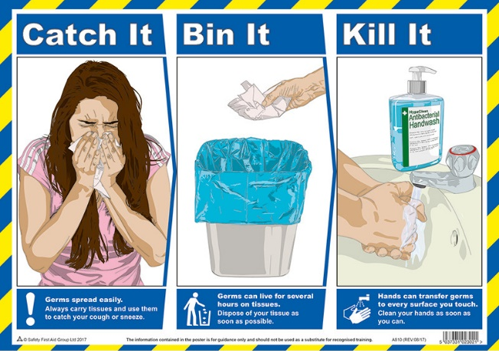
Do
- wash your hands with soap and water often – do this for at least 20 seconds
- always wash your hands when you get home or into work
- use hand sanitiser gel if soap and water are not available
- cover your mouth and nose with a tissue or your sleeve (not your hands) when you cough or sneeze
- put used tissues in the bin straight away and wash your hands afterwards
- try to avoid close contact with people who are unwell

Don't
- do not touch your eyes, nose or mouth if your hands are not clean
If you think you might have coronavirus, have been to a country or area with a high risk of coronavirus in the last 14 days or you've been in close contact with someone with coronavirus ring NHS 111. Visit https://www.nhs.uk/conditions/coronavirus-covid-19/ for further details.
Preventing and Managing Sickness
Information for staff, visitors and building users
STAGE 3 - MITIGATE/DELAY

We have currently increased precautions in place to ensure effective prevention of the spread of illness.
All users of the building are asked to follow the following guidance.

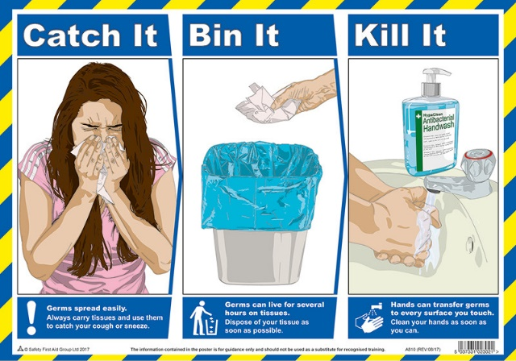
Do
- wash your hands with soap and water often – do this for at least 20 seconds
- always wash your hands when you get home or into work
- use hand sanitiser gel if soap and water are not available
- cover your mouth and nose with a tissue or your sleeve (not your hands) when you cough or sneeze
- put used tissues in the bin straight away and wash your hands afterwards
- try to avoid close contact with people who are unwell

Don't
- do not touch your eyes, nose or mouth if your hands are not clean
- enter the school if you are feeling unwell or have been in close contact with any person who is unwell (staff should contact the head teacher to discuss).

If you think you might have coronavirus, have been to a country or area with a high risk of coronavirus in the last 14 days or you've been in close contact with someone with coronavirus ring NHS 111. Visit https://www.nhs.uk/conditions/coronavirus-covid-19/ for further details.

