Places of Interest Related to this term’s learning and topic:
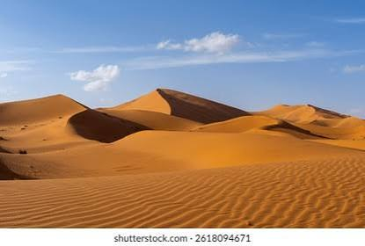
- Beacon Fell
- Martin Mere
- Harris Museum

Useful Websites Related To This Term’s learning
https://www.bbc.co.uk/teach/class-clips-video/articles/z3yxcxs

https://www.bbc.co.uk/bitesize/topics/ztyr9j6
https://www.bbc.co.uk/bitesize/articles/zyq9r2p

How Can My Parent Help Me?
Discuss places travelled in our county and other counties. Point out any landmarks and rivers. Talk about the differences and similarities between our local area and that of deserts. Discuss the challenges of living in deserts and think about how things survive that live there. Encourage you children to think back in time and the ingenuity of the Vikings. Was there a Viking presence in Bilsborrow? Investigate the Cuerdale Hoard: a local and recent discovery of Viking treasures.
This term pupils will be learning about the very interesting topic of the Vikings in history, along with the deserts in geography .Our science learning this year has a high biology content which starts with classification and moves onto life cycles later in the term.
Autumn Term Curriculum Learning Booklet
Science: talk to your children about different plants and animals. How do things in nature differ? What are the similarities? How can they be grouped?
Please listen to your child read at least 2-3 times a week. Whilst junior children are able to read independently, the level of comprehension and understanding needed really ramps up in Y5/6. Ask questions about the text as your child reads –ask them about their opinions, and what they think may happen next. Please also support your child to complete their homework. This enables important concepts to become embedded.
Christian Values
Our Christian Value this term is
Compassion.
Our vision is ‘Believe and Achieve’.
We will be thinking about these in every- thing that we do this term, along with our whole school ‘Big question’.
Some Key Vocabulary
Evolution, inheritance, DNA, natural selec-
tion ,ancestor, reproduction , generation , fossilisa- tion, adaptation, natural selection, fossil. Agriculture ,airstrip,,arid,barren,,biome,
climate, desert, desertification, drought,
flash flood,mushroom, rock,national, park
natural arch,,nature reserve,,rainfall,
ranching,,renewable energy,,,salt flat

sand dune

sparse

time zone

tourist attraction

vegetation

Thank you for all your continued support. Any questions please get in touch with me by catching me on the yard or by email: cirwin@johncross.lancs.sch.uk.

Katherine Rundell
In this topic you will learn...
English | To start with, the children will be reading the adventure novel, The Explorer, by Katherine Rundell. This book is a fantastic read, and won the Costa Children's Book Award. We will follow this with a rather gruesome book: Beowulf. This will complement our history topic ( The Vikings) as well as stimulate skills in creative writing where using language to create imagery will be a focus.
Maths | This half-term the children will be learning place value, division and solving word problems associated, Roman numerals, adding, subtracting and multiplying fractions and percentages.
Science | In science this term, Class 4 will first be studying the topic of ‘Classification’ of different vertebrates and invertebrates . This will be followed after half term by our life-cycle topic.
Art/D.T | Art:. Exploring how drawing can be used to express ideas and messages, inspired by a range of street art examples and environmental themes.  D.T. Mechanical systems: Pop-up book - we will create a functional four-page pop-up story- book design, using lever, sliders, layers and spacers to create paper-based mechanisms.
Geography | Our desert topic answers the question, ’ Would you like to live in a desert? We will be doing this by examining hot desert biomes starting with mapping the world's major deserts and investigating the physical features of the Mojave Desert.
History | Exploring the Viking age by learning about Viking raids, trade, settlement and the struggle for control of Britain.
PSHE and RSE | Both year groups will be learning about families, relationships and citizenship. They will developing an understanding of families, including marriage and what to do if someone feels unsafe in their family; learning that dealing issues can strengthen a friendship; exploring the impact of bullying and what influences a bully's behaviour;
P.E | This term, children will be learning invasion game skills, with a focus on netball initially followed by rugby. They will also have weekly swimming lessons.
Music | This term the children will learn about blues music , along with Christmas carols for the Junior Carol Service.
R.E | During the first half term the children will be learning about how and why Christians read the Bible.. After this, they will explore how Christians prepare for Christmas.
Computing and Online Safety | Y5 and Y6 are taught Computing and Online Safety The children will then be looking at computer research ( which includes safe searching) and this will be followed by a topic on AI.
French | In French, the children will be learning about the different types of transport as well as all about shopping in France. Through these topics, they will learn how toplan, ask and answer questions in French, use a bilingual dictionary to check the spelling and meaning of words and find new vocabulary. They will learn to extend sentences using connectives and a range of adjectives, give and justify their opinions, and apply accurate sound-spelling links.

Questions to get you thinking…
Our BIG question is ‘Are We Looking After God’s Creation ?
What are the challenges of living in a desert?
Why are our summers becoming hotter? How do animals adapt to live in hot climates?
Why did the Vikings chose to attack England? Where the Vikings really as vicious as their reputation suggests?
What are the challenges of living in a desert

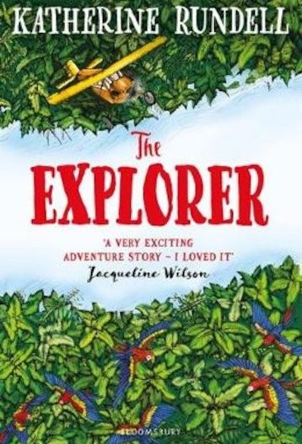
Important Information for this term
P.E kits to be worn every Thursday and Friday.
Swimming lessons resume on Friday 11th September
Harvest Festival service will be held with the children at St. Hilda’s on Sunday 27th September.
Weekly spelling test every Tuesday. All other homework to be completed every Tuesday.
School closes for end of half term Friday 23rd October.
Message from the teachers
Welcome back to school for a new school year in Year 5/6. we have some exciting
topics, learning experiences and trips planned this year, along with our annual residential at Winmarleigh in the spring term. Within this booklet there is a curriculum breakdown of what we will be covering this term in each subject. On the school website, www.johncross.lancs.sch.uk , there is a yearly overview of topics taught in each subject, as well as our subject and class pages where information and photographs can be found.
If you have any further questions or queries, then please speak contact me. Thank you very much.
Mrs Irwin

