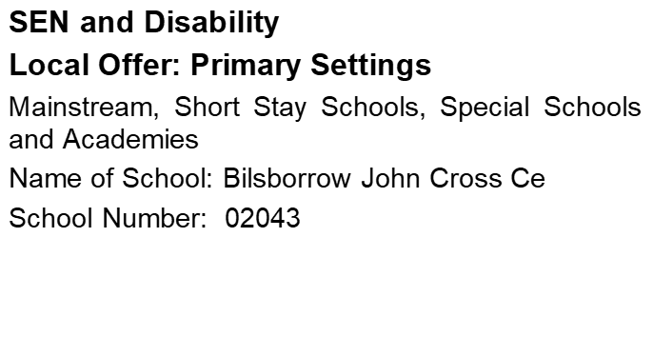

School/Academy Name and Address | John Cross CE Primary School  Bilsborrow  Preston  PR3 0RE |  |  | Telephone  Number | 01995 640505
School/Academy Name and Address |  |  |  | Website  Address | www.john.lancsngfl.ac.uk
Does the school specialise in meeting the needs of children with a particular type of SEN? | No | Yes | If yes, please give details:
 | NO
What age range of pupils does the school cater for? | Primary (3-11)
Name and contact details of your school’s SENCO | Mrs Megan Spedding  01995 640505  m.spedding@johncross.lancs.sch.uk

We want to ensure that we keep your information up-to-date. To help us to do this, please provide the name and contact details of the person/role responsible for maintaining details of the Local Offer for your school/academy.

Name of Person/Job Title | Mrs Sara Manzoor  School Business Officer
Contact telephone number | 01995 640505 | Email | bursar@johncross.lancs.sch.uk

Promoting Good Practice and Successes

I confirm that our Local Offer has now been published on the school/academy website.

Please give the URL for the direct link to your school’s Local Offer | https://www.johncross.lancs.sch.uk/
Name | John Cross CE Primary School | Date | 24.09.26

Please return the completed form by email to: IDSS.SENDReforms@lancashire.gov.uk
LOCAL OFFER: SEN Disability

Accessibility and Inclusion

Our school is situated on the A6 and there is no parking on site or around school. We do however have access to the large village hall car park which is close to school. Children have to cross a minor road from the car park to school.
The school has standard sized door frames and no steps. There is an accessible toilet facility.
Displays are placed on boards in the corridor, classrooms and noticeboards. Policies and procedures are accessible via the school office and school website.
We do not currently have any children or families with additional needs that require adaptations to information, resources and equipment.

Teaching and Learning

The school uses a robust method of assessment and needs are identified and targeted as soon as they are recognised. Children learn in small groups and differentiated plans meet their needs. Where children have additional behavioural or academic needs they are supported with Individual Plans that are tailored to each child. We currently have a high adult to child ratio that ensures children make above average progress. We access other agencies to support staff with children with additional needs.
The SENCO attends cluster meetings and relevant training pertinent to the needs of the children in school. The Headteacher attends briefings and updates. Information from the SENCO and Headteacher is cascaded to all staff at staff training meetings.
Where children require adjustments and support during SATS the Headteacher applies to the Department for Education for allowances to be made.
Our SEND provision map indicates that children with SEND make progress in line with all the other children in school.

Reviewing and Evaluating Outcomes

Where children have a Statement or EHC Plan the SENDCO will arrange for review meetings to be held annually. During the year the SENDCO liaises with parents and other involved professionals.
Children with other SEND support needs are monitored closely and reviewed regularly. IEPs or IBPs are discussed with parents and children and targets modified as required.
The school assesses and evaluates the effectiveness of its SEND provision by rigorously monitoring progress. Where the SENDCO and Headteacher feel needs are not being met they will take advice from other agencies and ensure guidance is implemented. Parents are regularly and consulted throughout the process.

Keeping Children Safe

Risk assessments are a regular part of school life and where children have additional needs these are always considered.
Children are welcomed into school from 8.45am although a staff member is on duty on the school yard from 8.40am. At the end of the school day children are not allowed out of the building until a known adult arrives to collect them. Older children are only allowed off the school premises independently if their parent has given verbal or written permission to school.
There are no parking areas on the school site but as stated above we do have access to a large nearby car park.
Break times are supervised by a member of staff and lunch times are supervised by two members of welfare staff.
All staff follow safe procedures at all times and ensure that pupil safety is a priority.
Parents can access the policy on school behaviour and anti- bullying from the school website or office. Ofsted (March 2023) states,
‘‘Staff expect pupils to behave well. Children in Nursery and Reception listen carefully to their teachers. As they grow up through school, this positive behaviour continues. Pupils are respectful, thoughtful and kind. They behave well in lessons. Teachers make sure that everybody keeps to the rules. Pupils enjoy being part of this calm and orderly school.’

Health (including Emotional Health and Wellbeing)

Medication is kept in a locked cupboard in the school office. Parents are asked to call into school to administer prescription medicines.
Inhalers or other prevention medicines can be kept in the classroom and children can access these according to need. It is common practice to ensure that inhalers are always taken on trips and excursions.
Where a child requires a care plan the school takes advice from the relevant professionals and ensures that all staff are aware of personalised needs.
In the case of a medical emergency the school will call immediately for an ambulance. First Aiders will respond in accordance with training. Staff train for children’s particular needs as they arise. All teaching staff and teaching assistants are first aid trained.
Where children require particular health or therapy services the school is committed to meeting their needs. School currently utilises play therapy services. There is a defibrillator located in the school office.
7 members of school staff are all first aid trained.

Communication with Parents

Parents at our school know that they can talk readily to the class teacher about any concerns. The school takes all concerns very seriously and acts on them immediately. We operate an ‘Open Door Policy’ although do ask that parents make an appointment to discuss things that might require an in depth discussion.
Parents are updated about their child’s academic progress at Parents’ Evenings twice a year and via a school report. Teachers will contact parents where they feel the children are not sustaining progress or if they have other concerns. The school holds Open Days once or twice a year.
Parents provide feedback about the school via the Ofsted Parent view Website and regular Governor questionnaire.
The school website is regularly updated with information, along with the private school Facebook group.

Working Together
The Headteacher holds regular meetings with the children in Years 5 and 6. This is an opportunity for the children to express their views about school. We have a worship team where children plan and lead worships.
Parents are given opportunities to discuss their feelings about their child’s education at all meetings. They are made fully aware that they can readily contact the class teacher and Headteacher about concerns.
All parents are welcome to attend the PTFA Friends Of Bilsborrow School (FOBS) meetings and events. Parents can apply to become Parent Governors when elections are due.
School welcomes parents into school to help with a range of curricular and extra- curricular activities, along with celebration assemblies and collective worship.
There is an SEND Governor who liaises with the SENDCO and Headteacher when discussing policies and provision.

What help and support is available for the family?

The SENDCO always offers help with completing paperwork and directs parents to Parent Partnership for any additional support. The SENDCO will help all families access the support they need.
Where a child needs help getting to and from school the school will work with the agency appointed and ensure that they liaise for the best interests of the children.

Transition to Secondary School

The school has a good relationship with local secondary schools. The children attend many events at Garstang Community Academy from Years 4 upwards. Our school ensures the children are prepared in Year 6 by enabling transition visits to their chosen secondary school.

Extra Curricular Activities

Breakfast club starts at 8am and provides breakfast. After School Club is open until
5.30pm.

The school holds a range of lunch time clubs and after school clubs throughout the year; these include gardening, construction, sports, Christian Union and football clubs. Where school involves an external agency, parents will be charged but where possible activities are free.
School works hard to ensure all children make friends in school. Lunch time staff focuses on helping the children play together well.

