JOHN CROSS CE PRIMARY SCHOOL

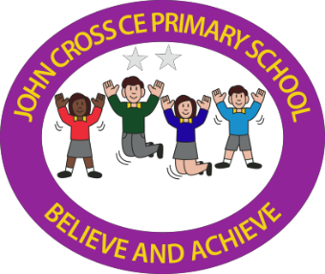

HANDWRITING POLICY

November 2022

Our aim is for children to develop legible, fluent, efficient handwriting.

Children must be able to write with ease, speed and legibility by the end of Year 4. If they have difficulty, this will limit fluency and inhibit the quality and quantity of their work. It is important that each child’s handwriting becomes an automatic skill that requires little effort and thought so that creative and physical energy can be focused on the content of writing rather than upon the act.

Cursive handwriting teaches pupils to join letters and words as a series of flowing movements and patterns. The style should be practised from an early stage. Pupils will learn to form individual letters appropriately and accurately first, with digraphs being taught as a joined unit and children will start to join other letters when they are ready but by Year 2 at the latest. This development is clearly linked to phonic development and learning. There is a clear link between spelling and handwriting.

Handwriting skills should be taught regularly and systematically. The Cambridge PenPals for Handwriting scheme of work is available in school. Principles from this scheme, from the National Handwriting Association and from the National Curriculum document Developing Early Writing have all been used to inform this policy.

Aims

We aim for children to:
- Achieve a neat, legible style with correctly formed letters in cursive handwriting.
- Develop flow and speed.
- Eventually produce the letters automatically and in their independent writing.

In order to achieve these aims, the following principles are followed:

Teaching and Learning

- Handwriting is taught regularly and systematically in all classes, groups or individually as appropriate.
- Handwriting is practised regularly in classes throughout the week in a discrete and explicit way.
- Patterns are used initially, by writing with a variety of tools and using multisensory methods, to help free flowing hand motions.
- Correct pencil hold, sitting position and letter formation are taught from the beginning, and handwriting is frequently linked with phonics or spelling.
- When marking or writing comments, members of staff should use the precursive or cursive handwriting style adopted in this school.

Skills for handwriting need to be introduced from a very early stage. Activities which encourage children to develop controlled movements – both in terms of fine and gross motor control – should be addressed through all kinds of play and cross-curricular opportunities. Children should be allowed to pick up the writing implement themselves and decide which hand they prefer. As children begin to discover their preferred hand for holding a pencil and once they are confidently using flowing movements, they can be introduced to smaller, more controlled activities.
Through these, left ➔ right hand movements can be reinforced, moving from the top to the bottom of a letter and reinforcing the anti-clockwise movement, etc.

The handwriting style adopted for early writing at this school is found in Appendix 1 and is the precursive style with clear lead in strokes for all lower case letters. Joins are introduced as soon as children are ready and by Year 2 at the latest for the vast majority of children

It is important that there is consistency across the school and all staff should follow the agreed protocols within this policy.

National Curriculum for KS 1 & 2, September 2014

We follow the requirements for teaching handwriting in Y1-6 in England from the revised National Curriculum 2014.

Quotes concerning handwriting taken from the text:

Pupils who do not learn to read and write fluently and confidently are, in every sense, disenfranchised (‘Purpose of Study’ p13)
Pupils should develop the stamina and skills to write at length, with accurate spelling and punctuation. (6.3 Language and literacy - Reading and Writing)
Writing also depends on fluent, legible and, eventually, speedy handwriting. (Programmes of study and attainment targets - Aims of English p15).

Detailed requirements for Years 1-6: Programme of study (statutory requirements) | Notes and guidance (non-statutory)
Year 1
Pupils’ writing during year 1 will generally develop at a slower pace than their reading. This is because they need to encode the sounds they hear in words (spelling skills), develop the physical skill needed for handwriting, and learn how to organise their ideas in writing.
Pupils should be taught to:  - sit correctly at a table, holding a pencil comfortably and correctly  - begin to form lower-case letters in the correct direction, starting and finishing in the right place  - form capital letters  - form digits 0-9  - understand which letters belong to which handwriting ‘families’ (i.e. letters that are formed in similar ways) and to practise these. | Handwriting requires frequent and discrete, direct teaching. Pupils should be able to form letters correctly and confidently. The size of the writing implement (pencil, pen) should not be too large for a young pupil’s hand. Whatever is being used should allow the pupil to hold it easily and correctly so that bad habits are avoided.  Left-handed pupils should receive specific teaching to meet their needs.
Year 2
In writing, pupils at the beginning of year 2 should be able to form individual letters correctly, so establishing good handwriting habits from the beginning.
Pupils should be taught to:  - form lower-case letters of the correct size relative to one another  - start using some of the diagonal and horizontal strokes needed to join letters and understand which letters, when adjacent to one another, are best left unjoined  - write capital letters and digits of the correct size, orientation and relationship to one another and to lower case letters  - use spacing between words that reflects the size of the letters. | Pupils should revise and practise correct letter formation frequently. They should be taught to write with a joined style as soon as they can form letters securely with the correct orientation.

Lower Key Stage 2 – Years 3 and 4
Joined handwriting should be the norm; pupils should be able to use it fast enough to keep pace with what they want to say. Pupils’ spelling of common words should be correct, including exception words and other words that they have learnt. Pupils should spell words as accurately as possible using their phonic knowledge and other knowledge of spelling, such as morphology and etymology.
Pupils should be taught to:  - use the diagonal and horizontal strokes that are needed to join letters and understand which letters, when adjacent to one another, are best left unjoined  - increase the legibility, consistency and quality of their handwriting, e.g. by ensuring that the downstrokes of letters are parallel and equidistant; that lines of writing are spaced sufficiently so that the ascenders and descenders of letters do not touch. | Pupils should be using joined handwriting throughout their independent writing.  Handwriting should continue to be taught, with the aim of increasing the fluency with which pupils are able to write down what they want to say. This, in turn, will support their composition and spelling

Upper Key Stage 2 – Years 5 and 6
Please note that there are no specific objectives for the teaching of handwriting at upper Key Stage 2. This is because children entering Year 5 should have already acquired all the basic skills for handwriting to enable them to concentrate on the legibility, fluency, speed and personal style of their writing. In light of this, children who are writing legibly and fluently in Year 5 may choose different font styles to develop a personal style.
Pupils should be taught to:  - write legibly, fluently and with increasing speed by:  - choosing which shape of a letter to use when given choices and deciding, as part of their personal style, whether or not to join specific letters.  - choosing the writing implement that is best suited for a task (e.g. quick notes, letters). | Pupils should continue to practise handwriting and be encouraged to increase the speed of it, so that problems with forming letters do not get in the way of their writing down what they want to say. They should be clear about what standard of handwriting is appropriate for a particular task (e.g. quick notes or a final handwritten version). They should also be taught to use an un-joined style (e.g. for labelling a diagram or data, writing an email address, or for algebra) and capital letters (e.g. for filling in a form).

Children need to be able to write legibly, neatly, comfortably and quickly. Teaching handwriting to the majority of children is not difficult but there are certain stages that are crucial to successful learning:
Step 1 Pre-writing experience

To develop good handwriting a child needs strength and stability in his/her body. This gross motor control can be developed in the playground and in PE sessions, for example, crawling, jumping, running, hopping, arm circling, ball skills.
Writing involves using a tool to make small, controlled movements. This fine motor control can be developed by activities such as cutting, threading, modelling, hammering, finger rhymes, sorting small objects, sticking, pattern-making & tracing. Children in the Early Years also take part in Dough Gym activities to develop their fine motor control skills.
A child needs to have developed perceptual skills before he can write. Working with shapes, patterns, objects in different sizes and sorting can assist this development.
When a child is writing, attention should be given to comfort - the furniture, body position and ease of movement - and encouraged to hold the pencil in a way that gives both control and flexibility.

Step 2 Letter formation

In British schools the lower case alphabet is usually taught before the capital alphabet. How to form each letter should be taught at the same time as children are introduced to the letter’s shape and sound.
A visual image and a verbal description help a child to remember the movements necessary to form letters. One set of images recommended by the Department of Education groups the letters according to the movement made when forming them.
Each 'family’ has a leading letter:
l - long ladder c - curly caterpillar
r - one-armed robot z - zig-zag monster
Letter should be formed from the base line as the starting point is easy to remember, with the exception of o, r, v, w as joined letters following these do not start from the baseline. Requiring children to relearn an established movement pattern is not good practice.

Step 3 Letter positioning

In written English letters need to be aligned in a conventional way to be easily read. Children need to understand that the ‘body’ of each letter sits on a line, some letters have ascenders that are taller and some have descenders that drop below the writing line.
Children need to understand that letters in a word should be evenly spaced. In addition there
needs to be sufficient space between each word and the next. Recommending that small children use their finger as a spacer between words is not a good idea as it is impossible for left-handers and becomes inappropriate when children are older and their writing becomes smaller. A more reliable rule is to leave enough space for a letter ‘o’ and/or use a spacer instrument.

Step 4 Joining letters
A child who writes correctly-formed letters with confidence is usually ready to learn how to join them together. There are three ways of teaching children joined writing:

- Pattern making
Children who have plenty of experience making writing patterns, both standard handwriting patterns and those made from linking pairs of letters (e.g. cl, wh), will find that they have all the skills necessary for joined writing and little additional teaching is necessary.
- Groups of letters
A blend of letters being taught in a phonics lesson can be joined together when demonstrated by the teacher and practised by the children in the air or on small whiteboards. (NB some letter combinations are easier to join than others.) The children who are confident can be encouraged to use the joins in free writing.
3 Basic joins
These can be taught in a series of lessons with plenty of practice:
- Diagonal (up the hill join) to a long ladder letter, both tall and short (e.g. c-u, i-l)
- Horizontal (washing line join) to both tall and short letters (e.g. o-u, w-h)
- Joins to curly caterpillar letters (e.g. u-c, n-d)

  - Capital letters for the initial letter of names, then for sentences, should be established in the Foundation stage in line with Developing Early Writing. The use of a capital letter for the pronoun ‘I’ should be introduced in Year 1. All capital letters should be fully embedded by the end of Year 2. The English curriculum 2014 programme of study for Year 1 states that pupils should be taught to:
    - punctuate sentences using a capital letter and a full stop, question mark or exclamation mark
    - use capital letter for names of people, places, the days of the week, and the personal pronoun ‘I’

Capital letters should be formed separately and should not join adjacent letters.

Step 5 Fluency
Children are expected to write in greater quantity and at greater speed as they grow older and will need functional handwriting that will allow them to do this. They need to be able to write automatically so that their attention can be given to the content of their writing.
Fluency can be developed by:
    - using joined writing in all situations so it becomes a familiar skill
    - using handwriting patterns
    - helping students to assess their own writing and monitor their progress.

Step 6 Speed
Children are expected to write fluently and accurately at speed with a good level of legibility. They also need to understand:
    - that different tasks require different levels of speed and legibility, e.g. for personal notes speed is usually important and legibility less so
    - that work for display or presentation requires a high level of legibility and presentation but that speed is less important.

In addition, there are expectations for children and staff across the school. Pupils are expected to:
    - Look after exercise books and not draw or scribble in or on them.
    - Write the date on the top left hand side of the page and miss one line before writing a title aligned centrally. These should be underlined using a ruler.
    - Miss one line after the title before writing begins.
    - Plan their work to make it look attractive and well presented.
    - Use rulers to draw straight lines.
    - Set out, number and annotate work appropriately.
    - Pupils with special educational needs or exceptionally able pupils may progress at different rates at the discretion of the class teacher.
    - At appropriate times pupils may be encouraged to experiment with alternative means of presenting their work for aesthetic or educational reasons.

Teachers are expected to:
- Ensure that classrooms are well equipped with the essential tools that will assist pupils to create work with a high presentational standard.
- Organise the classroom in such a way that materials and resources are easily accessible and systems for their return and maintenance are robust.
- Ensure that children look after resources and materials so that good value for money is assured including consumable items such as pens, pencils, crayons, erasers, rulers etc.

Date of Policy: February 2019
Member of staff responsible: L. Reynolds Date to be reviewed: Autumn 2022

Appendices
Appendix 1 | Cursive handwriting – letter formation
Appendix 2 | Letter formation with rhymes sheet
Appendix 3 | National Handwriting Association Tips for Teaching series

Appendix 1 Cursive Handwriting Letters

All letters lead in from the writing line and join at the writing line, unless otherwise stated. Descenders are looped.

Half Height Letters
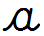
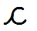
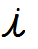

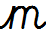 Centre stroke meets line
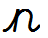
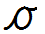Leads in from line; joins from top

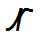 Leads in from line; joins from top
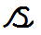
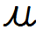

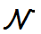Sharp v, leads in from line; joins from top

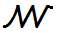 Sharp w, leads in from line; joins from top
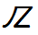 Straight z

Letters with ascenders

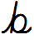 Leads in from line; joins from top
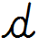

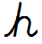
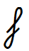Looped top and back 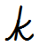 Looped style
May be slightly shorter than other ascenders. Cross stroke from ascender.

Letters with descenders

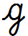
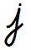
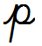

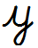
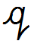Flick stroke to join

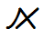

Appendix 2
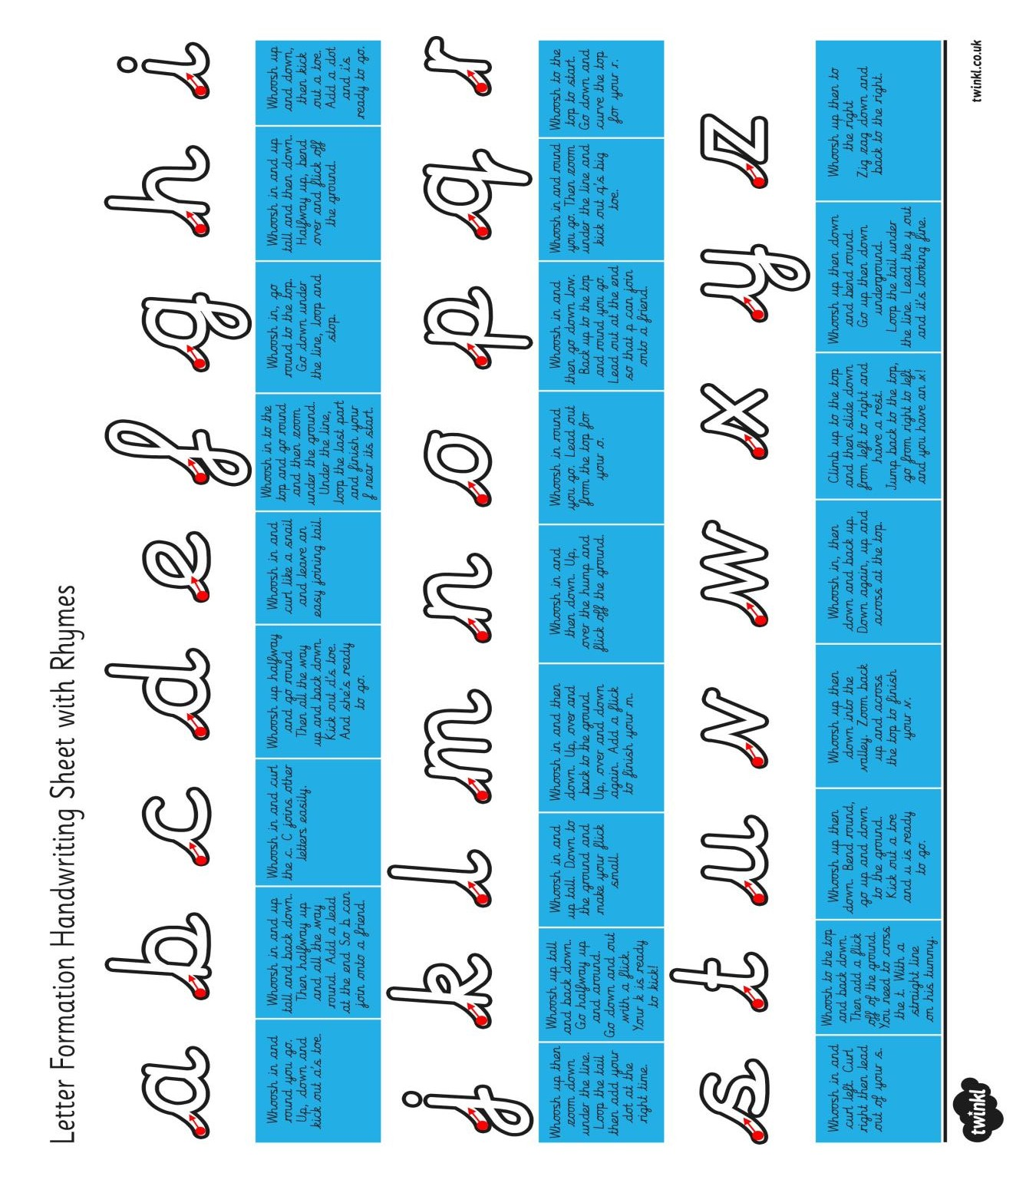

Appendix 3



