Newsletter Date 27th September 2024
Autumn Term 1

Christian Value this term: Compassion
Colossians 3:12: ‘Therefore, as God’s chosen people, holy and dearly loved, clothe yourselves with compassion, kindness, humility, gentleness and patience.’
‘Do to others as you would have them do to you’.

John Cross CE Primary School Newsletter

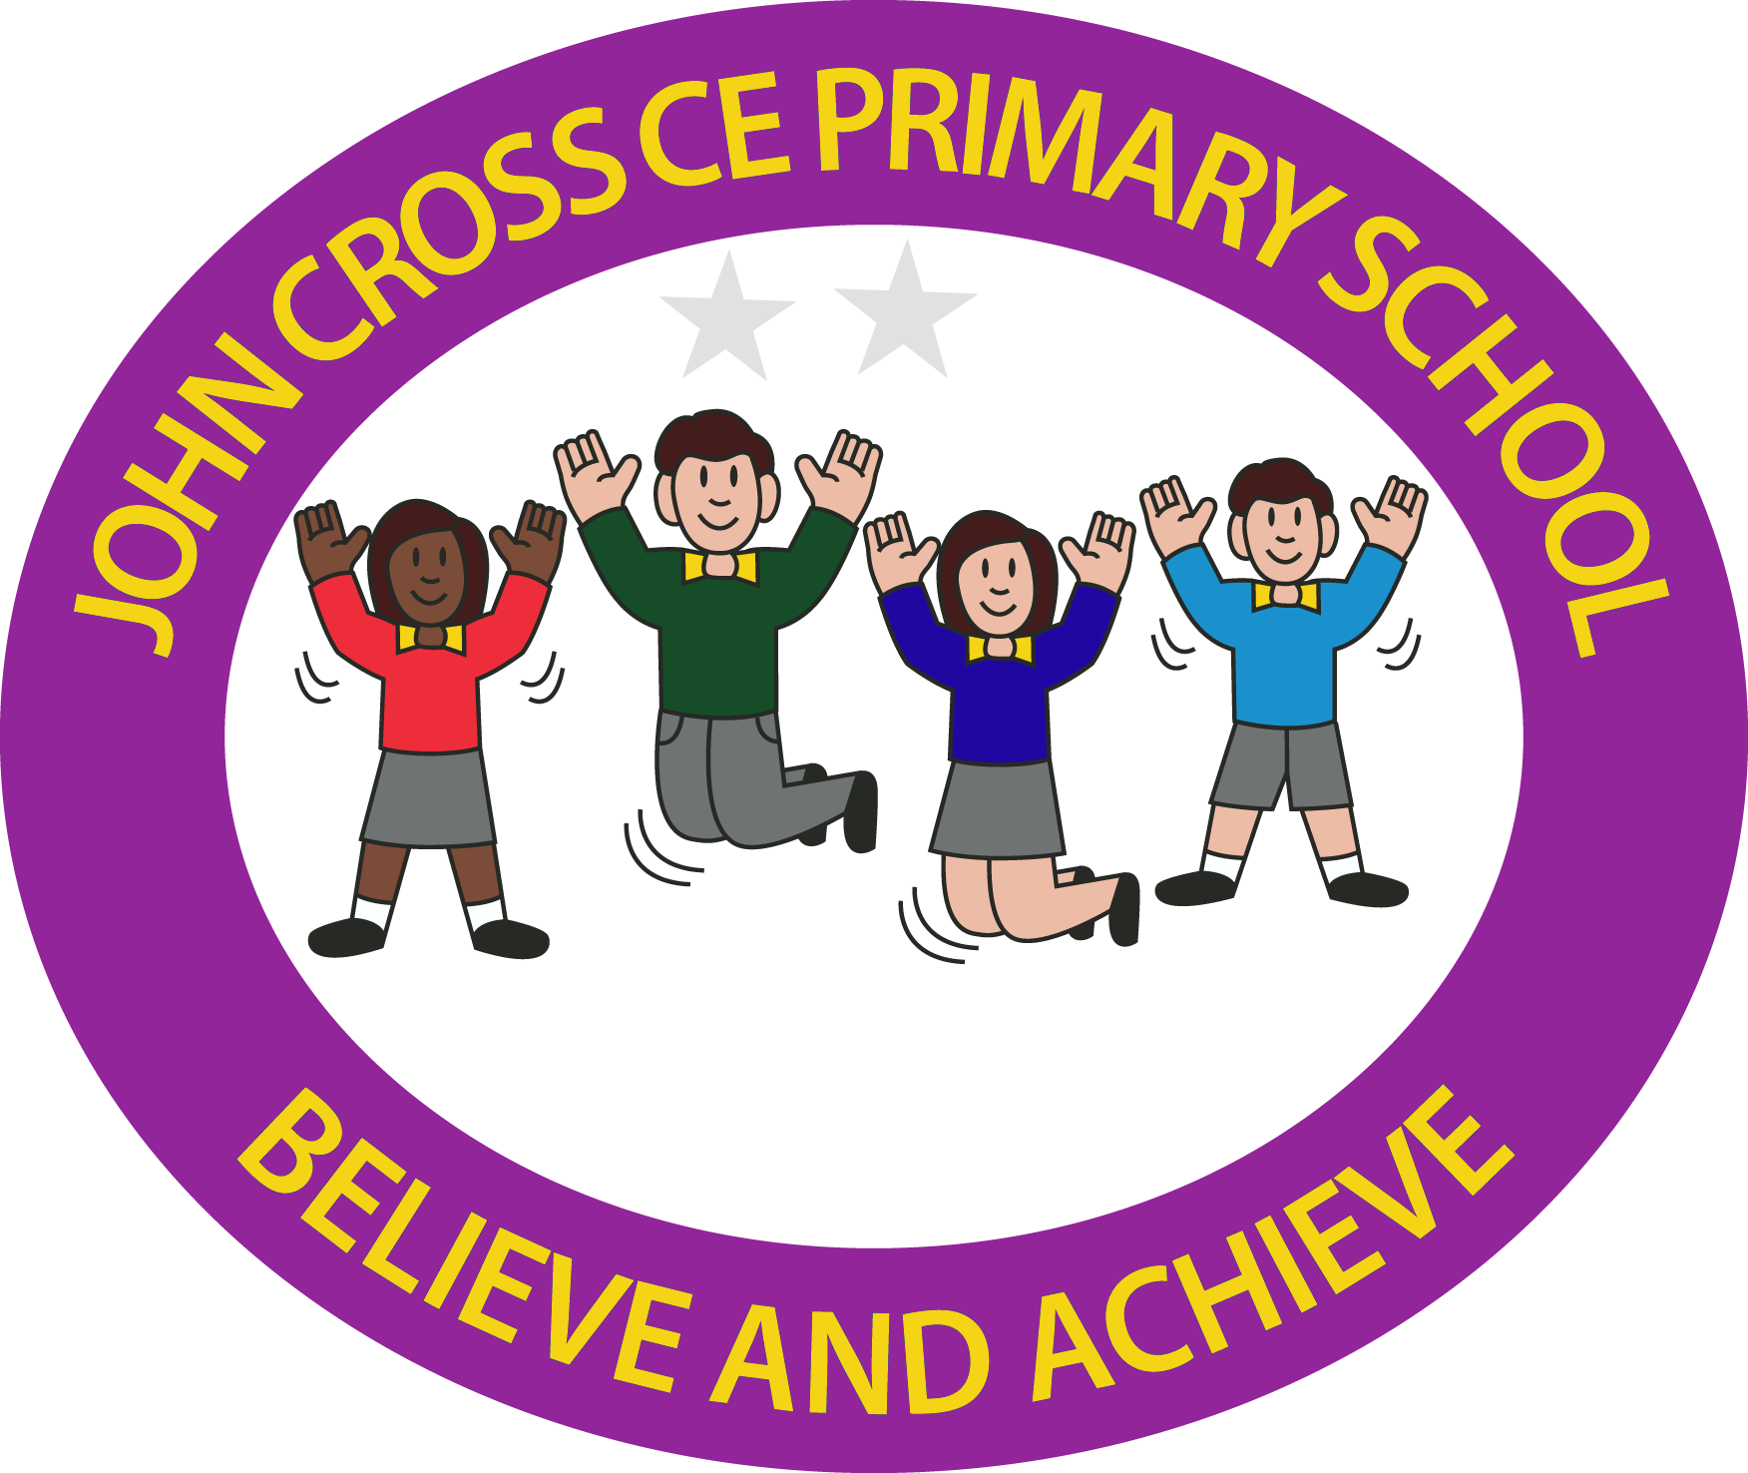

‘Life in all its fullness’.

This week…

Calendar Dates
26/9/24
Yr 5/6 Boys/Girls Football Competition at GCA 7-a-side, GCA, 4pm-5pm
2/10/24
OPEN DAY, all welcome, 9am-6pm
8/10/24
Y3/4 trip to Ribchester Roman Museum
10/10/24
Yr 3/4 Boys & Girls Football Coaching & Competition, 7 -a- side, GCA 4pm- 5pm.
15/10/24
Parents Evening
18/10/24
Close for half-term
28/10/24
School re-opens
6/11/24
Start school day at St.Hilda’s
11/11/24
Remembrance service, Bilsborrow memorial
15/12/24
Infant Nativity in church
16/12/24
Junior carol service in church

Thankyou
To all of the children who attended the Harvest festival service at St.Hilda’s last Sunday – it was great to see so many of you there. Well done for the acting, reading and puppet show you put on – I had a lot of lovely comments from the church congregation about how good they thought you were! Photos from the service are on the next page.
Thank you also to Myerscough College for delivering a huge amount of free plants, furniture and cobbles for our outdoor project, it will really help to make it look established. We are currently waiting for the gazebo to be delivered, along with timber for the path leading to the area and fencing for the pond area. Hopefully this will be completed in the next few weeks before half-term so the children and staff can start to use it.
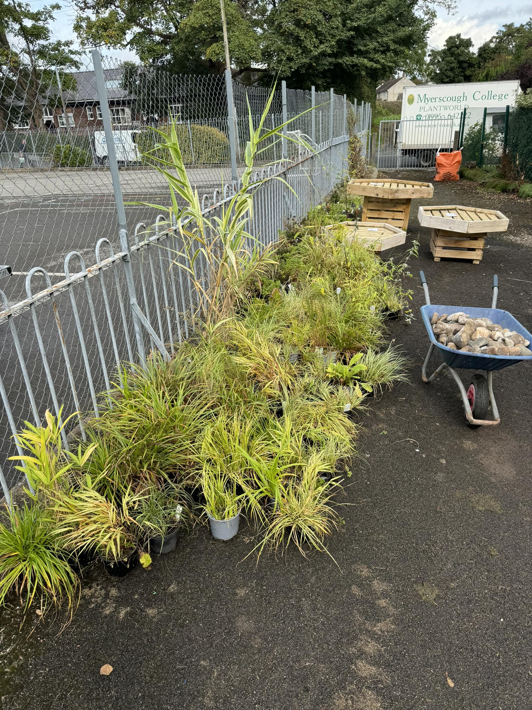

Road Safety
It has been brought to my attention that at the start of the day, a number of children have been running across the road from the village hall carpark, to the rear school yard gate, without looking first for traffic. Please can you remind your children about road safety and crossing. Can I also remind parents that staff will only take charge of minding the children on the yards at 8.40pm, and that parents are responsible for children until then.
Pupil information
We still do not have everyone’s pupil data information sheet back from parents, which is essential so staff have up to date contact numbers, any health needs/ allergies etc for the children. Please ensure these are returned asap if not done already, thank you.
Class information
Please use the school website to see class pages, and what the children have been learning each week. Staff will be updating them over the course of each term. These can be found here:
https://bilsborrow-john-cross-ce-primary-school.secure-primarysite.net/class-pages/
We also post on the school’s private Facebook group, messages and work the children may have done that day, the group is here: https://www.facebook.com/groups/214377152954786
If you have requested to join the Fb group but still haven’t been authorized, please contact school – we have a lot of requests from profiles not linked to school, and it is difficult to see who is a parent or not!

Awards



Class 1 Good Work
All of Class 1 for brilliant balancing skills in PE!
Star Pupil: Hollie for trying really hard with her letter formation.
Class 2 Good Work
Esme for her learning in the continuous provision. (3D pictures).
Star Pupil: Alicia for working hard on the presentation of her work.
Class 3 Good Work
Hugo for a great painting based on Paul Klee.
Harrison for a great non-chronological report on his hybrid creature.
Star Pupil: Jessica for an excellent attitude to learning in all subjects.
Class 4 Good Work
Martha & Tilly for super descriptive writing in their backstory.
Star Pupil: Jake for a mature attitude and approach to his work.

Harvest Service
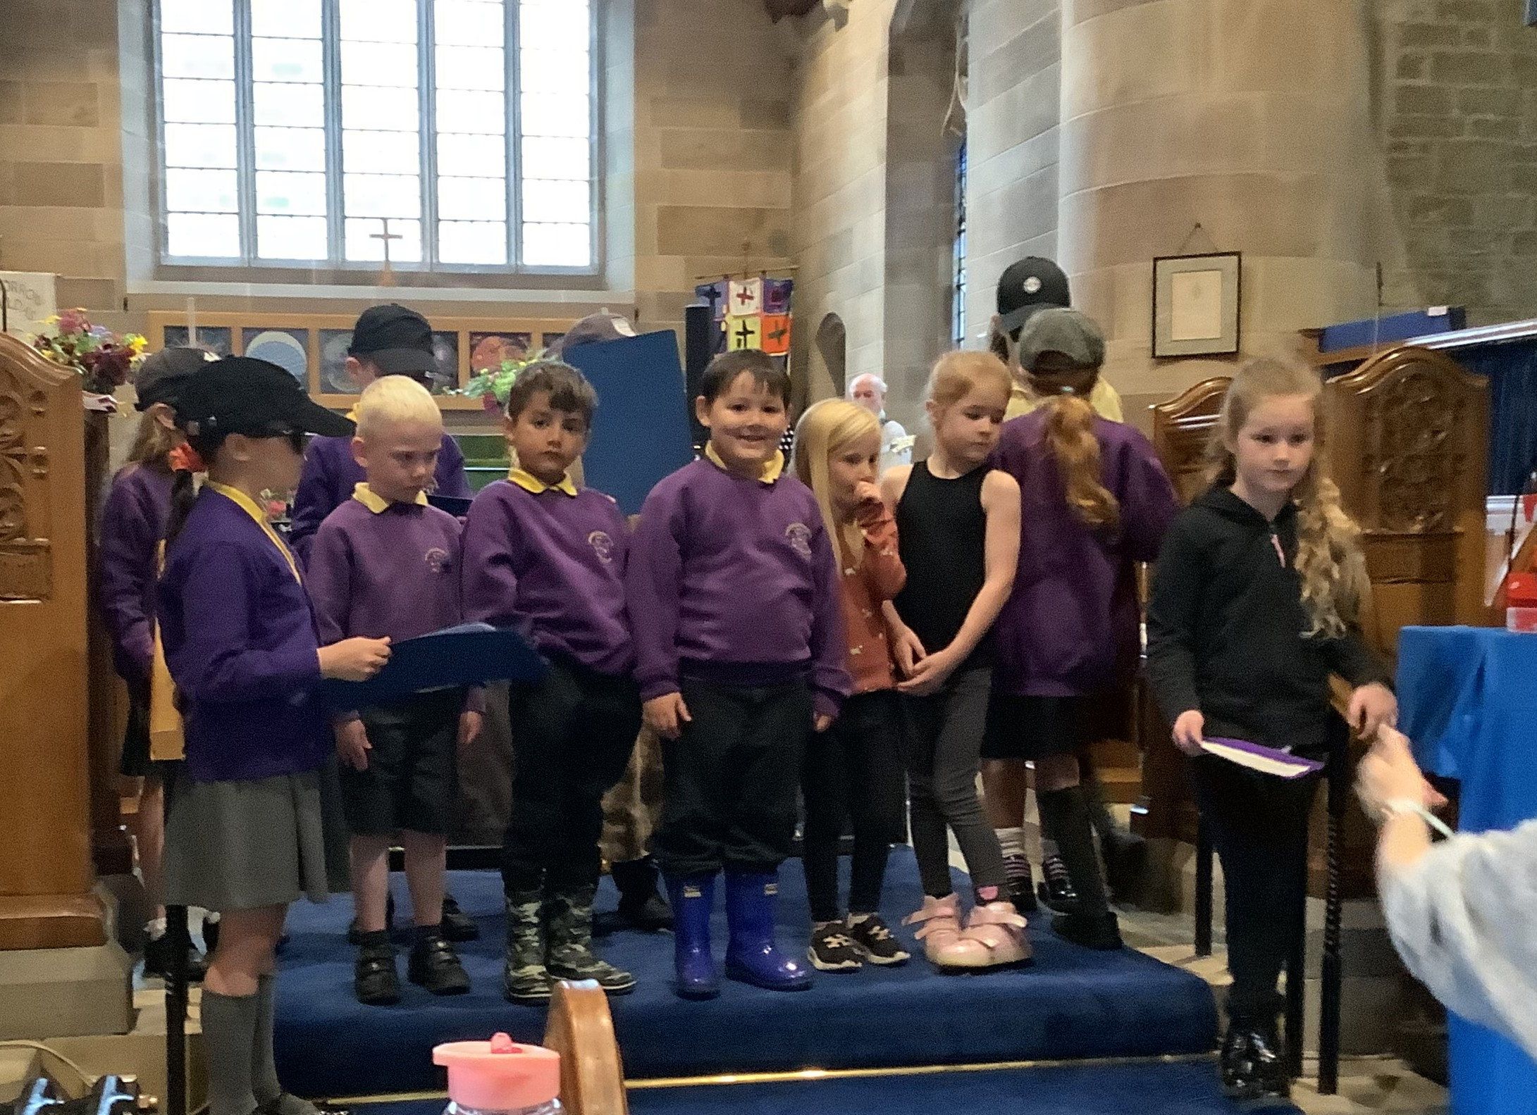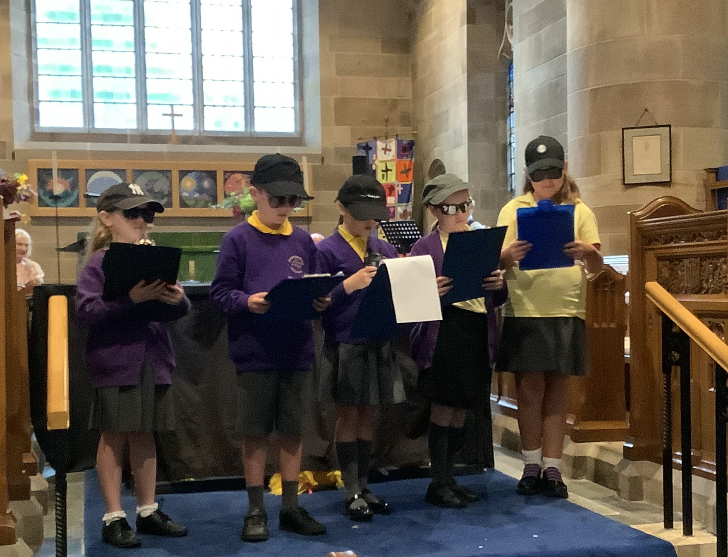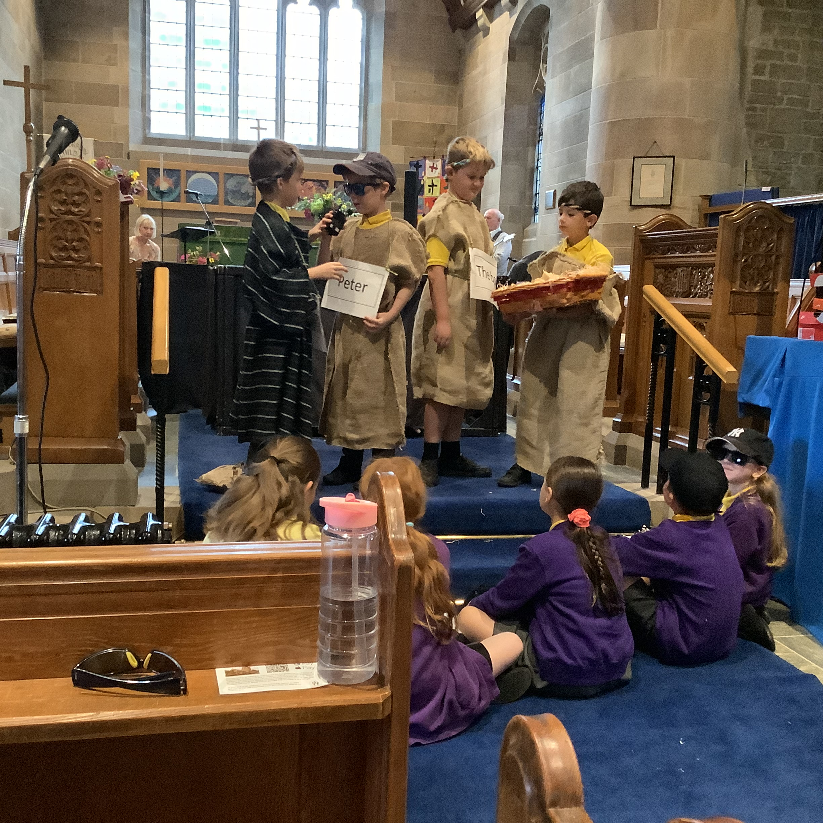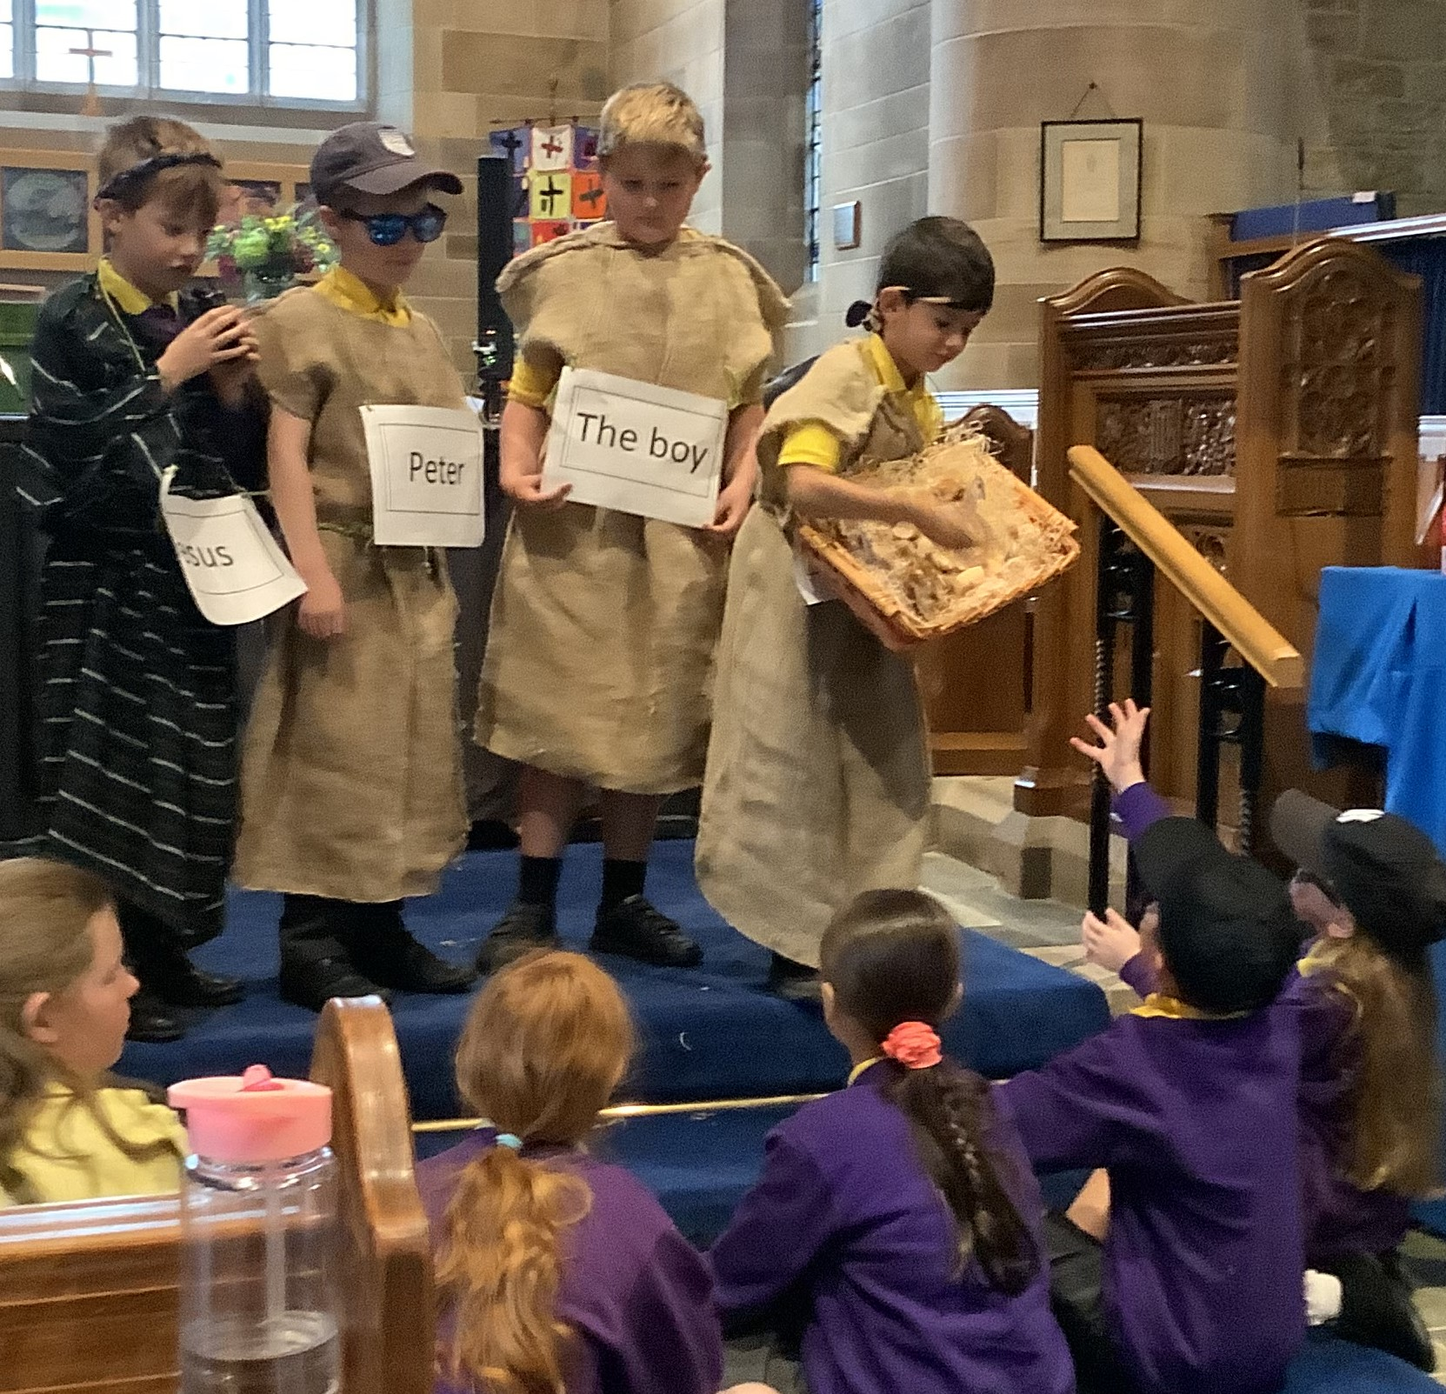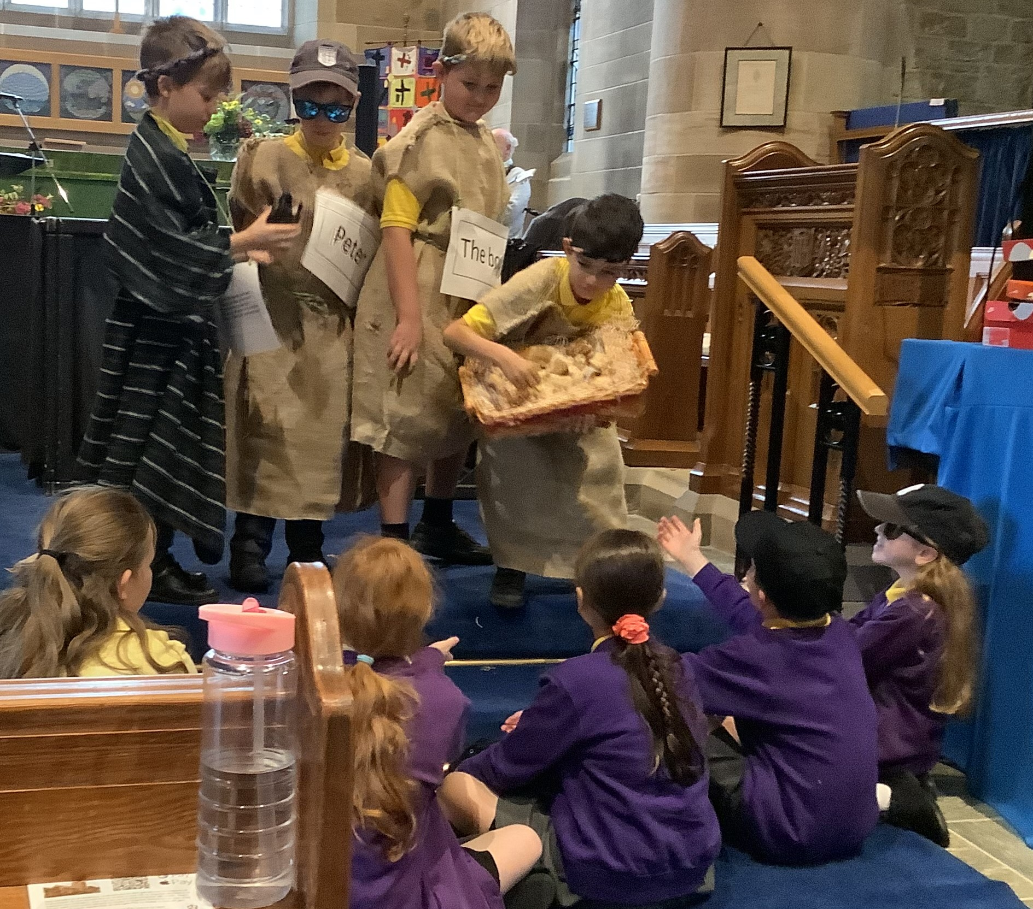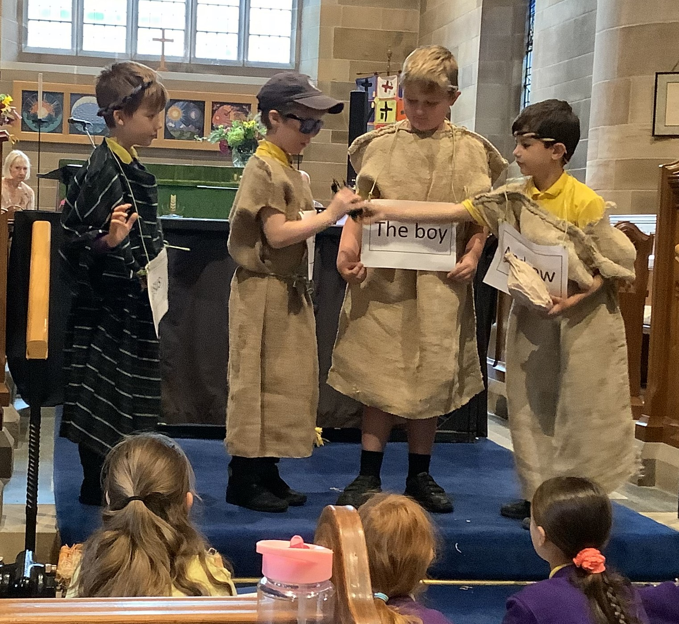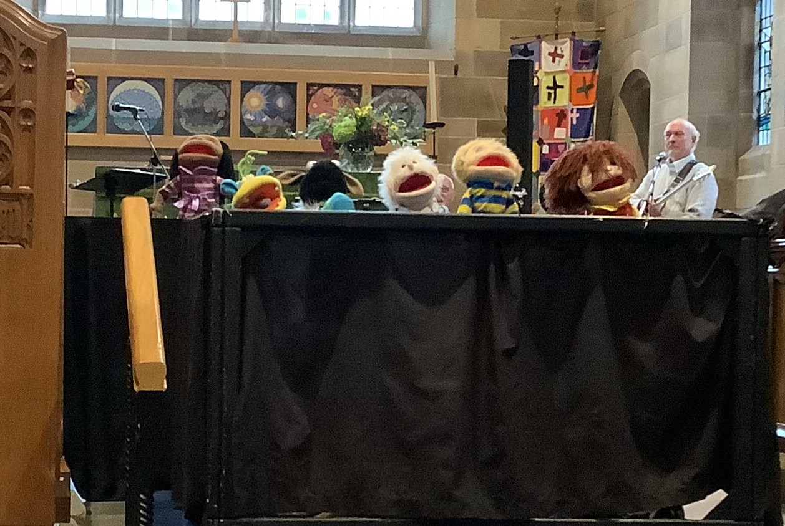

Page 2 of 4


Happy Birthday to the following pupil;
Archie Bamber

Have a great weekend everyone!

Mr Reynolds

